A Level (including AS Level) Accounting (9706)
What is the course book?
There is no single course book for the AS Level and A Level Accounting syllabus. The resource list gives a number of alternative books designed for A Level Accounting. In general, we would hope that teachers would make use of a variety of resources and encourage their students to do the same: at AS Level and A Level wide reading is to be encouraged. Moreover, students will often find that a topic which they do not understand when reading one book becomes much clearer in another book — yet the choice of best book will differ between topics and between students.
Where is the resource list?
It is one of the appendices in the syllabus booklet.
Should I assume that any book not on the resource list is inappropriate?
Not necessarily. As stated above, students and teachers quite legitimately prefer different books. CIE usually does not list books which are out of print (even though sections of them at least may remain very useful), or books which might be readily obtainable in only one of the countries where CIE's examinations are taken.
Where can I obtain the books on the resource list?
Most of the texts can be obtained over the internet. The following websites may be of interest:
Are there any teacher support materials for the syllabus?
Yes. There are specimen papers (with mark schemes) and there is a separate 'Standards Booklet' containing candidates' answers to some recent A Level questions and an indication of what AS Level grade these answers are considered to be worth. Past papers for the last two years are available for purchase from CIE Publications. The 'Report on the Examination' booklet published after each session gives guidance on Examiners' expectations and common candidate errors.
Are mark schemes published?
The mark schemes for the new syllabus are published, starting with that for the AS Paper for June 2001. They are available for purchase from CIE Publications.
Is the use of calculators allowed?
Yes. For details of the restrictions on graphic display, data banks, etc, which apply to all CIE examinations, see the Handbook for Centres.
Does a candidate have to pass each separate paper?
No. The candidate's grade is determined solely by the total number of marks they have earned (weighted according to the published weightings of the papers), so a good performance on one paper can make up for a poor performance on another paper.
What are the weightings of the papers?
Where can I find the keys to the multiple choice questions?
They are in the published 'Report on the Examination', which is sent to Centres that had entries about three months after the examination and can be sent to others on request.
Are marks deducted for wrong answers in the multiple choice?
No. The candidate's mark is the total number of questions answered correctly.
Are the A2 papers just on the A2 topics or do candidates have to revise the AS material as well?
Each of the questions on the A2 papers examines at least one A2 topic, but may also assume a knowledge and understanding of the topics covered in the AS syllabus.
Is the old syllabus available for re-takers in 2002?
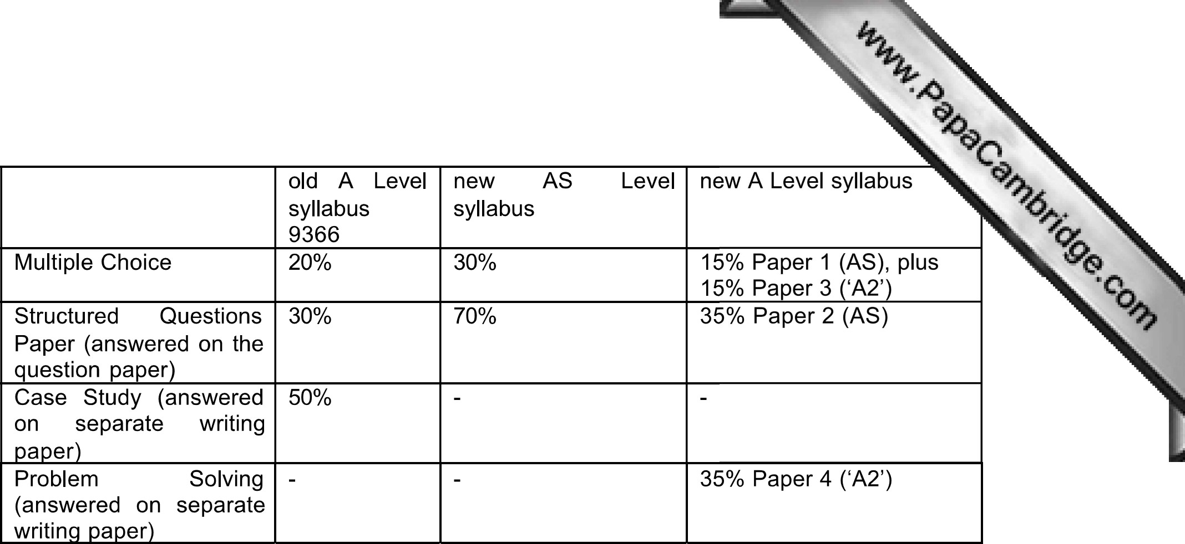
No. Candidates must take the new syllabus. There are not many differences in content between the old syllabus and the new one. They are listed in Appendix A of the syllabus booklet for the new syllabus.
Are candidates allowed a break between Papers 1 and 2?
If two papers are timetabled in the same morning or afternoon, as may sometimes be the case with Paper 1 and Paper 2 in future, Centres may allow the candidates a break of up to 15 minutes between the papers. Note that it is not acceptable to give out the second paper until the time allocated for the first paper has been allowed and the answer sheets have been collected.
Will AS Level multiple choice questions be as difficult as those for A Level?
They will be easier only in that AS Level topics are inherently easier than A2 topics. Also, individual AS Level question cannot draw on knowledge required only for the A2, but an A2 question could draw on knowledge of both the AS and the A2 parts of the syllabus. However, AS Level MCQs may be drawn from the bank of A Level MCQs on those topics, and the Specimen Paper reflects this.
Do we have to provide multi-column accounting paper?
No. Candidates obviously answer Papers 1 and 3 (multiple choice) on special machinereadable answer sheets. Paper 2 is answered on the question paper. For Paper 4, candidates may be issued with multi-column accounting paper, but this is not expected and it is not listed as a stationery requirement.
Are there marks for correct workings even if the answer is wrong?
Yes. It is very important for candidates to show their workings.
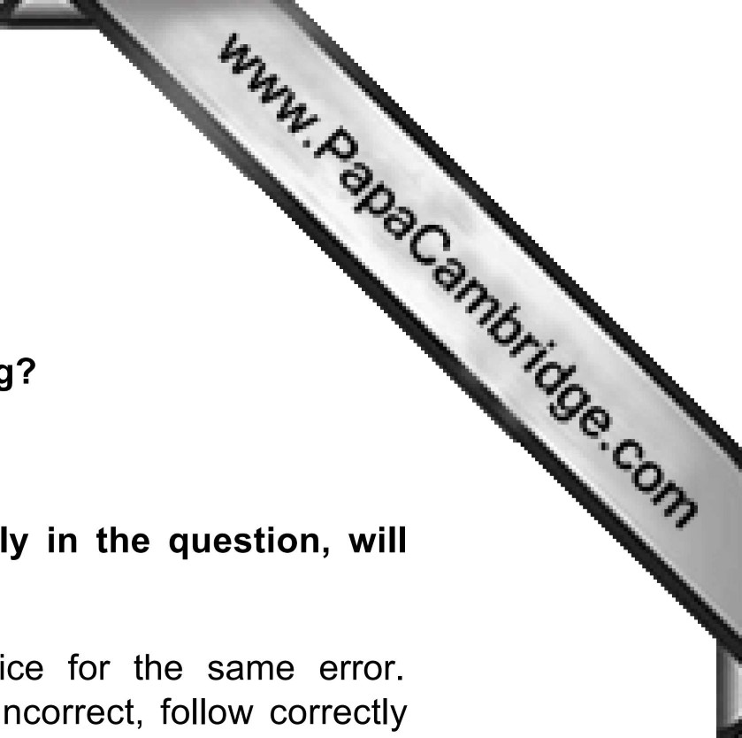
If a candidate makes an arithmetic or accounting mistake early in the question, will they then lose all the remaining marks for that question?
No. The principle is that a candidate may not be penalised twice for the same error. Examiners are instructed to allow marks for figures which, though incorrect, follow correctly from a candidate's previous error which has already been penalised. This is known as applying the 'own-figure' rule.

